# **Sprint 4 Plan Thru-Hiker** Sprint completion date: 5/27/24 Revision 1, 5/15/24

### **Goal:**

Clean up the app and add more trails.

### **Tasks:**

* + **High Priority User Story 2.1 [8 points]**

As a user, I want to receive the most up to date statistics and information on the app.

* + **Medium Priority User Story 2.2 [5 points]**

As a user, I want a smooth experience with minimal glitches and delays.

* + **Low Priority User Story 2.3 [3 points]**

As a user, I want to have more control and ability to select more trails.

Task 1: Fix bugs with coherency issues with health kit async queries.

Task 2: Fix bug with route progress pages.

Task 3: Add more trails

### **Roles:**

Gavin: Backend Lead

Kai: Front End Lead

Brandon: Developer/Scrum Master

Ayman: Developer

Taylor: Developer

### **Task Assignment:**

Gavin: User story/Task 1/3

Kai: User story/Task 2

Brandon: User story/Task 2

Ayman: User story/Task 1

Taylor: User story/Task 1

### **Initial burndown:**

### 

### **Initial scrum board:**

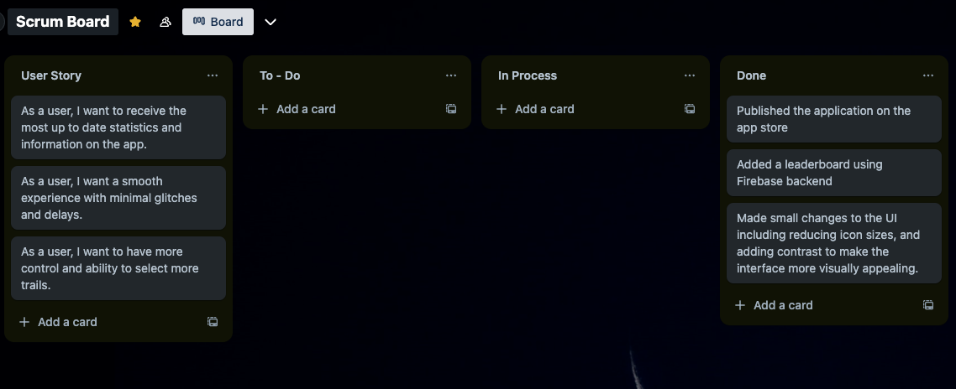

### **Scrum time:**

Monday, Wednesday, Friday 12-1pm. TA meeting on Friday 12-1pm.